Preparing our Campus for Reopening & Return to Work and School

Safety Is Our First Priority

• Wear your facial covering/mask
• Practice social distancing
• Stay home when you are sick; monitor your symptoms
• Disinfect your work station and area
• Clean and disinfect frequently touched objects and surfaces
• Wash hands often with soap and water for at least 20 seconds
• Pay attention and adhere to the signs that reinforce social distancing in high traffic areas
• Upon your return to campus, pick up and utilize your Disinfecting Kit (“Caddy”) to help you stay on the job safely and keep your area and environment clean and safe

THE CDC AND EXPERTS IN THE INDUSTRY SHARE A
“MOMENT FOR SAFETY”

Change, Expectations, and Solutions
THE COVID PANDEMIC WILL FOREVER CHANGE THE FACILITY MODEL

CHANGE AND EXPECTATIONS

✓Services, which have traditionally been seen as an operational expense, must be positioned as a critical component to maintain safe, clean, and healthy environments.
✓Campuses that simply look clean are no longer good enough. We must thoroughly disinfect multiple times per day.
✓Students, faculty, and the community will now demand visibility and transparency for custodial services.
✓An enhanced cleaning plan will be critical to foster confidence and stability.

SOLUTIONS

✓The Phoenix College Custodial Staff is positioned to help our students and staff prevent the spread of pathogens through a three-step approach to building disinfection.

Return Safely Through Transparent Operations
BUILDING TRUST THROUGH WELL DEFINED PROCESSES

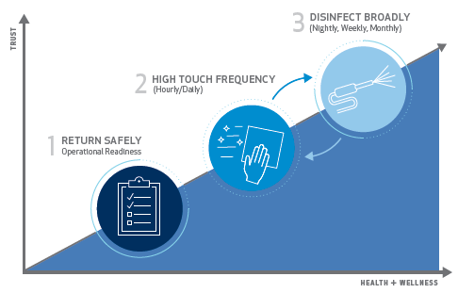

THREE KEY ELEMENTS OF THE PROGRAM:

• Processes Developed with Data From Local and National Resources (CDC, ADHS, MCHD, ASHRAE & AIA)
• EPA-Registered Disinfectants & Specialized Equipment
• Innovative Solutions and Technology

The Right Approach at the Right Time

Step 1: Return Safely

• Pre-opening site assessment(s) through early and often communication with departments

• New workforce protocols (i.e., social distancing procedures, social distancing occupancy strategy)

• Reentry disinfection service using EPA-registered disinfectants

• We clean and broadly disinfect all occupied areas once a day; we clean and disinfect restrooms in occupied areas twice per day; we disinfect high-frequency touchpoints twice per day

• Disinfecting Kits (Caddies) for all employees

Step2: Frequent High Touch Disinfection

• Increased frequency of disinfection of all high touch point areas in the facility

• All occupied spaces will receive a deep cleaning and disinfecting once per day, and high-touch surfaces will be disinfected twice per day. Restrooms will be cleaned and disinfected twice per day

• A custodial disinfecting log will be posted in the physical environment, typically near the restroom, for visible cleaning accountability and record keeping

Step 3: Broader Disinfection

• Larger areas may be disinfected using electrostatic spraying equipment or other means of mass cleaning technologies

